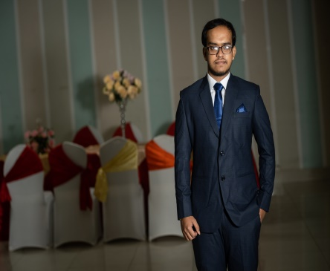**Shirdartho Bhowmick Tirtho**

145/1,R.K.Mission Road,Gopibag,Dhaka

[shirdartho2630@gmail.com](https://mail.google.com/mail/u/0/#inbox)

01981382151

**Linked-In :** [**Shirdartho Bhowmick**](https://www.linkedin.com/in/shirdartho-bhowmick-tirtho-0975111b8/)

**Github :** [**Tirtho304**](https://github.com/Tirtho304)

**Career Objective:**

Want to learn new things and implement my skill and knowledge to solve the problem of society and make better system in collaboration with team through different computer and mobile application.

**Summary View :**

I am studying my BSc in CSE from Daffodil International University. My current CGPA is 3.35 (till 6th semester).I have experience in building different mobile application on the online banking system, E-commerce, hotel management system and social media. I am very much passionate about Mobile Development.

**Technical Skills :**

* **Language :** C++, Java, Python, Dart, Mathlab.
* **Database :** MySQL, MongoDB, SqLite.
* **Android Skill :** Hybrid Application, Flutter, Android studio, Visual studio, SDK, Android architecture .
* **Research Interest :** Image Processing, Machine Learning.
* **Others :** Analytical Problem Solving , Leadership, Quick Learning ability.

**Education :**

1. **BSC in Computer Science and Engineering [ Result – 3.35]**

Institute : Daffodil International University [2019-2023]

1. **HSC – Passing Year : 2018 [ Result – 3.75 ]**

Institute : Birshrestho Munshi Abdur Rouf College [2016-2018]

1. **SSC – Passing Year : 2016 [Result – 5.00]**

Institute : Motijheel Model High School ,Dhaka.

**University Android Projects :**

1. **DIU LAB ASSISTANT :** It helps the teacher to store the lab experiment number and labfinal number.

**Language :** English and Bangla .